**Machine Learning Based Fall Prediction**

**Abstract**

Fall is an increasingly severe problem for aging population, especially for those who aged 65 or above. Among the cancer population, this rate is even higher for the reason that certain chemotherapy treatment will likely have a strong sedative effect that can affect patients’ motor function. In the past few years, many protocols were designed, aiming to detect falls in advance based on clinical tests, muscle functions, cancer type and other relevant indicators. In this study, we developed a machine learning-based algorithm, combined with clinical data, to create a model that can help clinicians effectively identify cancer patients under a high risk for falling at an early stage.

**1. Introduction**

The population is aging globally, and it has been estimated that about 900 million of the world population was aged 60 years. [1] For the aging population, fall has been the major risk factors that contributed to injury, disability, fracture and even premature death and greatly compromised old people’s independence and well-being. In 2015, over one-third of older adults experienced at least one fall more each year. [2]

The situation is even worse in aging cancer population for a couple of reasons. First, a lot of chemotherapy induced neuropathy, in which patients’ peripheral nerves are affected and symptoms’ like pain, numbness and tingling follow. Neuropathy can greatly undermine patients’ motor functions and increase their propensity for fall. [3] Besides, it has been found that polypharmacy is another a risk factor for falls among cancer population through adverse effects of drug-drug interaction. Previous fall studies have established that patients taking more than 4 drugs at the same time shows significantly increased incidence of falls. [4]

Fall assessment and pre-screening is characterized by the process during which the chance of future fall is likely to happen is estimated. In the past few years, a variety of fall detection procedures have been proposed that can be categorized into two main types. The first type relies on mechanical sensors that monitors patients’ physical activities on a continuous basis. This type of falling detection procedure can predict the fall with a high accuracy the moment an instant fall in occurring. However, this method normally works well only after the fall has already occurred and lacks the predictive power to detect the fall before it occurs. The second type of screening is based on patients’ clinical features like motor function, blood test, cognitive function. These models normally have a better predictive power in detecting fall in the future, but as a trade-off, this method has a much lower accuracy rate compared to sensor-based prediction.

In this study, we tried to develop a fall screening algorithm based on the clinical features collected from a sample of cancer patients who are over 65 years, using a couple of popular machine learning algorithm. Machine learning is a popular field that brings a lot of revolutionary power to the field of medicine in the past decades due to its superior predictive power and its ability to deal with high dimensional and nonlinear dataset like clinical dataset. We hereby wanted to see if those algorithms can bring more predictive power in helping clinicians successfully identify and detect cancer patients who are under a high risk of future falls.

2. **Methods**

2.1 Dataset

For the purpose of this work, two datasets were selected: Geriatric Assessment Intervention for Patients Aged 70 and over Receiving Chemotherapy for Advanced Cancer (GAP) and COACH (abbreviation for?). A total of 758 cancer patients under chemotherapy were selected. Of those patients, 187 reported on falls, 609 reported on impaired short physical performance battery (SPPB), 211 reported on impaired ADL. Other cognitive tests like GDS and GAP7 were also administered. 80 of them reported a low GAD7 score and 178 reported abnormal GDS score.

3.2 Participant Characteristics

Table 1 – Participants Characteristics

|  |  |
| --- | --- |
| **Characteristic N(%) or**  **Median (IQR)** | |
| **Sex** |  |
| Male | 390 (51.45%) |
| **Cancer Type** |  |
| GI | 214 (28.23%) |
| Lymphoma | 56 (7.38%) |
| Lung | 206 (27.17%) |
| GU | 100 (13.19%) |
| Gyne | 48 (6.33%) |
| Breast | 85 (11.21%) |
| Other | 49 (6.46%) |
| **Depression**  **Score (GDS)** |  |
| Impaired | 178 (23.48%) |
| **Time Up and Go (TUG) Test** |  |
| Impaired | 298 (39.31%) |
| **Adaptive Dynamic Learning** |  |
| Impaired | 211 (27.83%) |
| **Anxiety Score (GAD7)** |  |
| Impaired | 80 (10.55%) |
| **Blessed Orientation-Memory-Concentration Test (BOMC)** |  |
| impaired | 20 (2.6%) |

3.3 Sampling Techniques

In the dataset, there are a minority of fall classes compared to the ‘non-fall’ classes, leading to data imbalance. To solve this problem, either the fall class can be over-sampled, or the control class can be under sampled to balance the dataset. *Imbalanced-learn packages* [6] were used for the data resampling process. For the purpose of this study, SMOTE procedure was administered to synthesize elements for the minority class by picking up and computing k-nearest neighbors.

3.4 Supervised Learning

The fall detection classification are done through four following stages: pre-processing, feature selection, model training and cross verification. Binary classification standard is administered to sort the patients into faller and non-faller classes based on their clinical features alone. The following classification methods were implemented: neural network, support vector machine (SVM), logistic regression, decision trees and Naïve Bayes.

3.5 Feature Selection

Due to the high dimensionality nature of the dataset, feature selection algorithm is used to minimize the negative effect of dimensionality by eliminating features with lower weight. Besides, feature selection can be informative under clinical settings in that it can well indicate which features are most highly associated with falls. For the purpose of this study, we used recursive feature elimination using cross validation.

3.6 Model Evaluation

The overall performance of the models built are evaluated by four index: precision rate (sensitivity), recall rate (specificity), average precision rate [(precision sensitivity)/2] and area under the curve (AUC) value. Precision rate reflects model’s ability to detect the occurrence of all when there is indeed a fall. Recall rate measures model’s capability of capturing non-faller when the patient is not falling. AUC curve is a comprehensive measure of both true positive rate and false negative rate.

**3. Results**



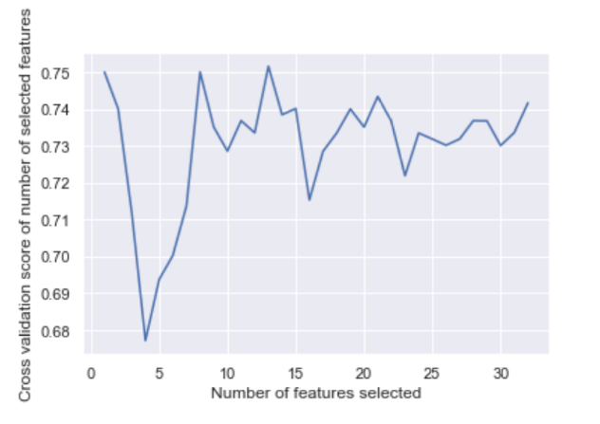

**Figure 1. Feature rankings and predictive cross validation scores for given feature numbers.** (A) Recursive elimination assigns each attribute with a weight and each attribute is ranked based on its weight. (B). Given different number of features used for model training, cross validation score varies and reaches the peak when top 13 features are selected.

**3.1 Feature Selection**

Feature selection algorithm shows that certain variables contribute more to the prediction of fall compared to others. Attributes like higher grade, certain cancer type, fear for future fall, health and age are the five most heavily weighted attributes associated with fall detection (**Figure 1A**). Next, we varies the number of important features selected from 1 to 20, and reiteratively calculates the cross validation scores. Tree-based recursive elimination algorithm gives the highest cross validation score when feature numbers are around 13 (**Figure 1B**).

Table 1. Logistic Regression for fall and non-fallers

|  |  |  |  |
| --- | --- | --- | --- |
|  | |  |  |
| **Variables Odds Ratio** | | **95% CI** | **p-value** |
| **Sex (M vs F)** | 0.64 | 0.42, 0.96 | 0.035* |
| **Impaired Polypharmacy** | 1.33 | 0.78 , 2.25 | 0.047* |
| **Living** | 0.76 | 0.59, 0.99 | 0.653 |
| **Driving** | 0.47 | 0.32, 0.70 | 0.0001*** |
| **Fh2** | 1.76 | 1.33, 2.31 | 0.0001*** |
| **Impaired TUG** | 0.66 | 0.50, 1.19 | 0.252 |
| **Impaired ADL** | 1.21 | 0.76, 1.92 | 0.418 |
| **Impaired Com** | 1.25 | 0.83, 1.90 | 0.279 |
| **Impaired MS** | 1.27 | 0.83, 1.95 | 0.262 |
| **Impaired IADL** | 1.41 | 0.89, 2.22 | 0.140 |

**3.2 Model Performance**

Table 2. Machine Learning Model Performance

|  |  |  |  |  |
| --- | --- | --- | --- | --- |
| Classifier | Accuracy  (%) | Sensitivity  (%) | Specificity  (%) | AUC Score |
| Logistic Regression | 53.51% | 72.35% | 72.81% | 69.00% |
| Multiple Layer Perceptron (MLP) | 53.43% | 65.39% | 70.81% | 70.00% |
| Random Forest | 52.19% | 73.99% | 73.97% | 71.00% |

**Table 1.** Model Performance by Accuracy, Sensitivity and Specificity

In terms of the accuracy, logistic regression gives the best outcome. However, random forest algorithm performs better in both sensitivity and specificity.

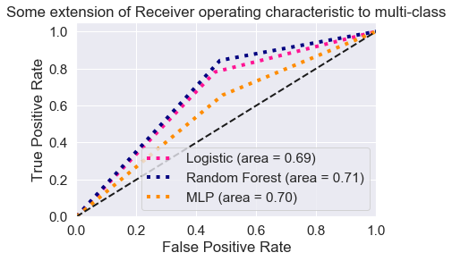

**Figure 2**. ROC curve and AUC score for logistic regression model, random forest model and MLP model are plotted respectively in the same graph. Random Forest returns the highest AUC score while logistic regression has the lowest AUC.

Both AUC score and recall/precision rate confirms that random forest algorithm has the best performance in terms of successfully detecting patients under high risk of fall and patients who are unlikely to fall (**Figure 2**). Logistic regression model’s performance and MLP model’s performance are similar in terms of AUC score. However, MLP model has lower sensitivity compared to the other two models.

4. Discussion

Compared to other previous similar studies in the field, we first introduced the sampling techniques into the clinical data to address the data imbalance problem. In the absence of sampling techniques, models trained based on the original dataset will normally result in a high specificity but low sensitivity because models will classify every single case into non-faller categories while still maintaining a decent accuracy rate. However, classifiers like that will be pointless because they fail to efficiently discriminate fallers from non-fallers.

In our study, we tried to achieve a high sensitivity model while trying not to totally sacrifice the specificity of the test. Random Forest performs the best in terms of both sensitivity (73.99%) and specificity (73.97%). Based on ROC curve, area under the curve (AUC) score approaches about 0.71. Performance of random forest is then followed by traditional logistic regression, which predicts fall with a sensitivity of 72.35% and a specificity of 72.81%. In comparison, although MLP model has a similar specificity, it has a worse sensitivity compared to other two models.

Feature selection showed that certain variable contributed more to the fall compared to other factors. Figure 1A illustrated that cancer type and cancer grades are two mostly heavily weighted predictors for fall. This result indicated that patients with certain cancer type of cancer grade might have a higher propensity for fall compared to others. To our surprise, other non-clinical features like income, insurance plan can also be used to predict future falls in cancer patients, which required future studies to further validate our outcomes.

Logistic regression indicated that gender, living, driving and FH2 are significantly associated with falls. Male cancer patients overall are 0.61 likely to fall in comparison to female counterparts (Z = -2.114, P = 0.035*). Patients who drive also have a significantly lower chance of fall compared to those who don’t (Z = -3.395, P = 0.001**). Besides, living condition is also associated with fall occurrence. Those who live in senior living facility and nursing home have a lower chance of fall compared to those who live alone (Z = -1.983, P = 0.047). Finally, patients who expressed fear of fall are also found to be more likely to fall compared to patients who are not worried about fall at all (Z = 3.81, P = 0.00001***).

5. Conclusion

[2] Burns, E.R.; Stevens, J.A.; Lee, R. The direct costs of fatal and non-fatal falls among older adults—United States. *J. Saf. Res.* **2016**, *58*, 99–103.

# [3]. Polypharmacy and falls in older people: Balancing evidence-based medicine against falls risk